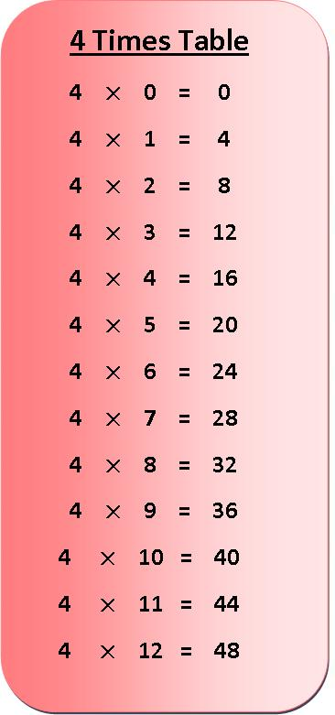
Active Times Table
Homework 3x & 4x
Bowling Times Tables

Practise the 3x and 4x tables and your
bowling skills!
Make skittles out of empty bottles, sticks or boxes. Write out the times table you are doing and stick to the skittles.
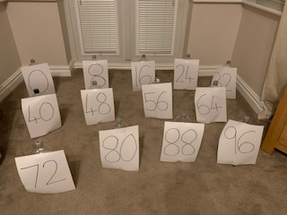
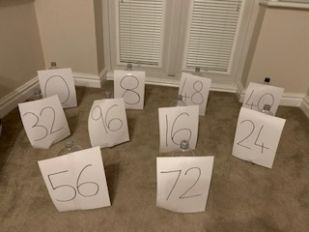
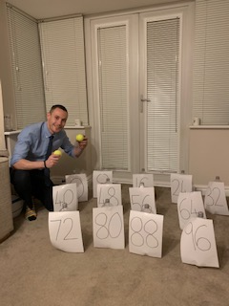
Say a times table and throw a ball to knock over the answer. Make your questions more challenging by mixing up the order of the numbers or adding more numbers.

Make your bowling more difficult by moving further away.

Can you encourage your parents, grandparents and siblings to join in too? Can you take a photograph or video of you taking part?
Challenge – Make a video of you practising and email to enquiries@ballifield.sheffield.sch.uk
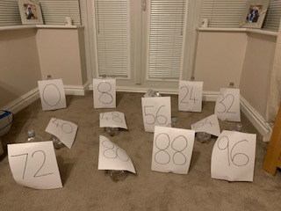
FAO Mr Cassidy / Mrs Jenkinson.

Ask your adults to post to the
school’s Twitter page
@Ballifieldpri #activehomework

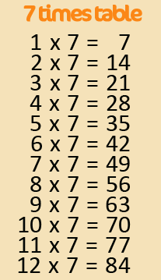
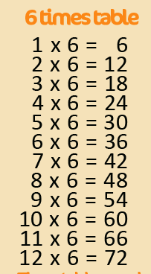
Active Times Table
Homework 6x, 7x, 8x
Bowling Times Tables

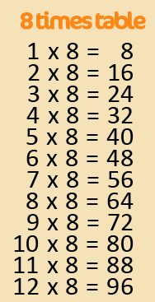
Practise the 6x, 7x and 8x tables and your
bowling skills!
Make skittles out of empty bottles, sticks or boxes. Write out the times table you are doing and stick to the skittles.
Say a times table and throw a ball to knock over the answer. Make your questions more challenging by mixing up the order of the numbers or adding more numbers.

Make your bowling more difficult by moving further away.

Can you encourage your parents, grandparents and siblings to join in too? Can you take a photograph or video of you taking part?
Challenge – Make a video of you practising and email to enquiries@ballifield.sheffield.sch.uk
FAO Mr Cassidy / Mrs Jenkinson.

Ask your adults to post to the
school’s Twitter page
@Ballifieldpri #activehomework

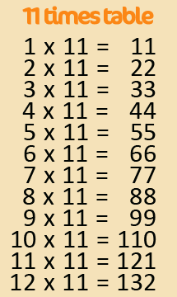
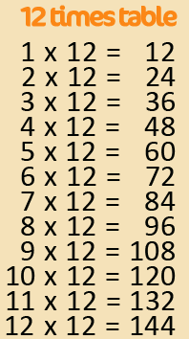
Active Times Table
Homework 9x, 11x, 12x
Bowling Times Tables

Practise the 9x, 11x and 12x tables and your
bowling skills!
Make skittles out of empty bottles, sticks or boxes. Write out the times table you are doing and stick to the skittles.
Say a times table and throw a ball to knock over the answer. Make your questions more challenging by mixing up the order of the numbers or adding more numbers.

Make your bowling more difficult by moving further away.

Can you encourage your parents, grandparents and siblings to join in too? Can you take a photograph or video of you taking part?
Challenge – Make a video of you practising and email to enquiries@ballifield.sheffield.sch.uk
FAO Mr Cassidy / Mrs Jenkinson.

Ask your adults to post to the
school’s Twitter page
@Ballifieldpri #activehomework

