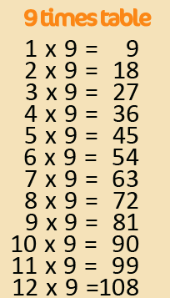
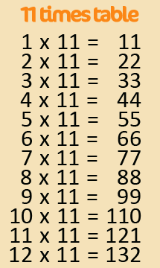
Active Times Table
Homework 9x, 11x & 12x
Star jumps Times Tables

Practise the 9x, 11x and 12x tables by doing
Star jumps.
One player – Find a space and do a star jump. Say your times table each jump.
Two player – A parent or a friend says the questions
and you do a star jump. You say the answer before landing.

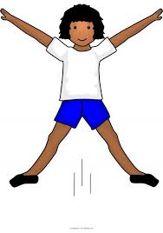

Can you make it harder by mixing the questions? Can you encourage your parents, grandparents and siblings to join in too? Can you take a photograph or video of you taking part?
Challenge – Make a video of you practising and email to enquiries@ballifield.sheffield.sch.uk
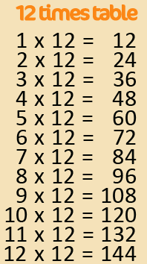
FAO Mr Cassidy / Mrs Jenkinson.

Ask your adults to post to the
school’s Twitter page @Ballifieldpri #activehomework
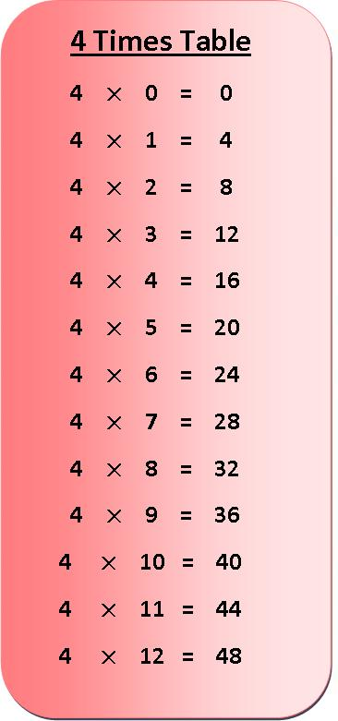
Active Times Table
Homework 3x & 4x
Star jumps Times Tables

Practise the 3x and 4x tables by doing
Star jumps.
One player – Find a space and do a star jump. Say your times table each jump.
Two player – A parent or a friend says the questions and you do a star jump. You say the answer before landing.

Can you make it harder by mixing the questions? Can you encourage your parents, grandparents and siblings to join in too? Can you take a photograph or video of you taking part?
Challenge – Make a video of you practising and email to enquiries@ballifield.sheffield.sch.uk
FAO Mr Cassidy / Mrs Jenkinson.

Ask your adults to post to the
school’s Twitter page @Ballifieldpri #activehomework

