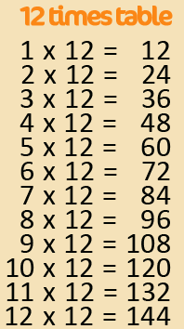
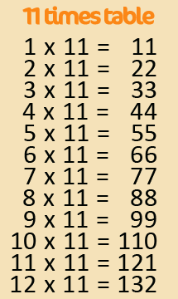
Active Times Table
Homework 9x, 11x, 12x
Football Times Tables

Practise the 9x, 11x and 12x tables by
playing football!
One player – Find a safe space to kick a ball against a wall. Say a times table question and kick the ball. Answer the question before controlling the ball. Repeat.
Two player – A parent or a friend says the questions and passes you the ball. You say the answer before controlling the ball. Pass back and repeat.

Can you make it harder by mixing the questions? Can you encourage your parents, grandparents and siblings to join in too? Can you take a photograph or video of you taking part?
Challenge – Make a video of you practising and email to enquiries@ballifield.sheffield.sch.uk
FAO Mr Cassidy / Mrs Jenkinson.
Ask your adults to post to the
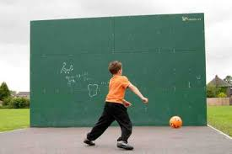
school’s Twitter page @Ballifieldpri #activehomework

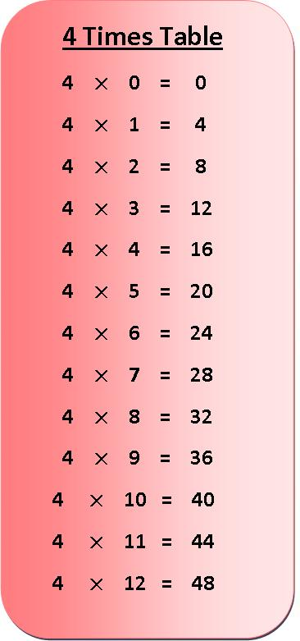
Active Times Table
Homework 3x & 4x
Football Times Tables

Practise the 3x and 4x tables by playing football!
One player – Find a safe space to kick a ball against a wall. Say a times table question and kick the ball. Answer the question before controlling the ball. Repeat.
Two player – A parent or a friend says the questions and passes you the ball. You say the answer before controlling the ball. Pass back and repeat.

Can you make it harder by mixing the questions? Can you encourage your parents, grandparents and siblings to join in too? Can you take a photograph or video of you taking part?
Challenge – Make a video of you practising and email to enquiries@ballifield.sheffield.sch.uk
FAO Mr Cassidy / Mrs Jenkinson.
Ask your adults to post to the
school’s Twitter page @Ballifieldpri #activehomework

