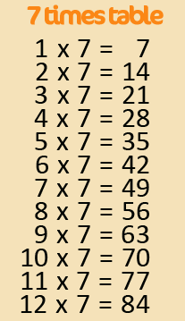
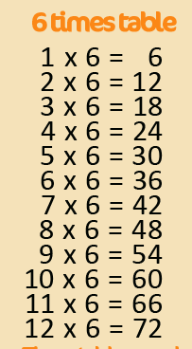
Active Times Table
Homework 6x, 7x, 8x
Burpees Times Tables

Practise the 6x, 7x and 8x tables and become fit and healthy at the same time!
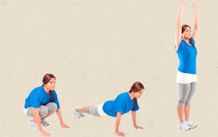
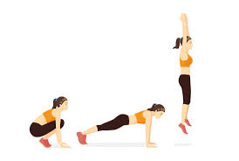
One player - Say your times tables fact and complete a burpee. Repeat.

Two player – Get your adult or friend to ask a times table question. Complete a burpee then answer the question. Repeat.

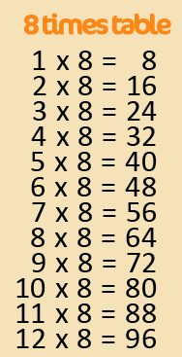
Can you encourage your parents, grandparents and siblings to join in too? Can you take a photograph or video of you taking part?
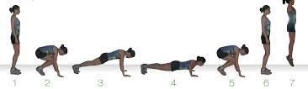

Challenge – Make a video of you practising and email to enquiries@ballifield.sheffield.sch.uk
FAO Mr Cassidy / Mrs Jenkinson.

Ask your adults to post to the
school’s Twitter page
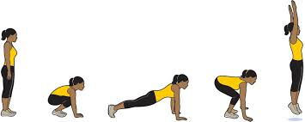
@Ballifieldpri #activehomework
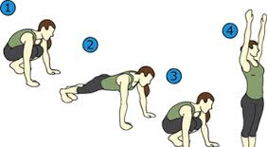

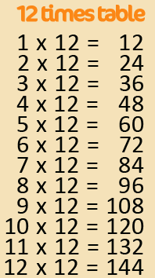
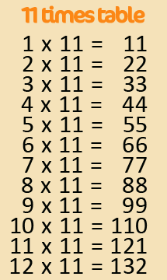
Active Times Table
Homework 9x, 11x, 12x
Burpees Times Tables

Practise the 9x, 11x and 12x tables and become fit and healthy at the same time!
One player - Say your times tables fact and complete a burpee. Repeat.

Two player – Get your adult or friend to ask a times table question. Complete a burpee then answer the question. Repeat.

Can you encourage your parents, grandparents and siblings to join in too? Can you take a photograph or video of you taking part?
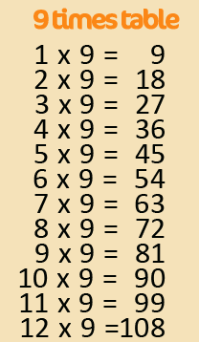

Challenge – Make a video of you practising and email to enquiries@ballifield.sheffield.sch.uk
FAO Mr Cassidy / Mrs Jenkinson.

Ask your adults to post to the
school’s Twitter page
@Ballifieldpri #activehomework

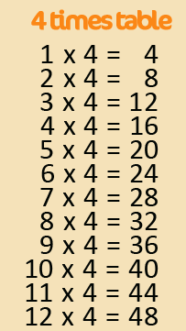
Active Times Table
Homework 3x, 4x,
Burpees Times Tables

Practise the 3x and 4x tables and become fit and healthy at the same time!
One player - Say your times tables fact and complete a burpee. Repeat.

Two player – Get your adult or friend to ask a times table question. Complete a burpee then answer the question. Repeat.

Can you encourage your parents, grandparents and siblings to join in too? Can you take a photograph or video of you taking part?

Challenge – Make a video of you practising and email to enquiries@ballifield.sheffield.sch.uk
FAO Mr Cassidy / Mrs Jenkinson.

Ask your adults to post to the
school’s Twitter page
@Ballifieldpri #activehomework

