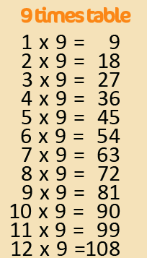
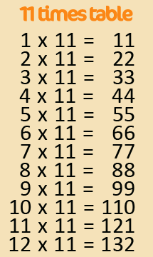
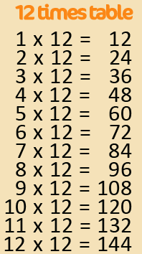
Active Times Table
Homework 9x, 11x, 12x
Hopscotch Times Tables

Practise the 9x, 11x and 12x tables and hopscotch together!

Make a hopscotch grid using your times tables. Use paper inside or chalk outside. Say the times table / answer the questions as you complete the hopscotch grid.

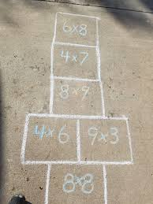
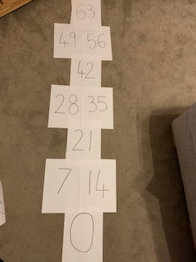
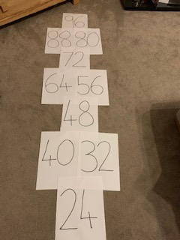
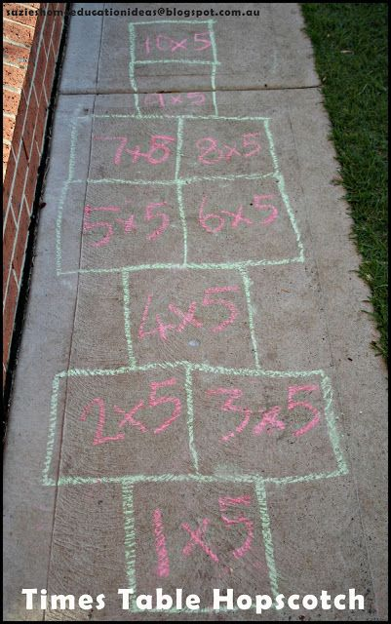

Can you encourage your parents, grandparents and siblings to join in too? Can you take a photograph or video of you taking part?
Challenge – Make a video of you practising and email to enquiries@ballifield.sheffield.sch.uk
FAO Mr Cassidy / Mrs Jenkinson.

Ask your adults to post to the
school’s Twitter page
@Ballifieldpri #activehomework

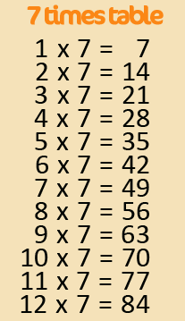
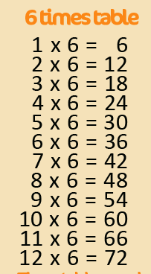
Active Times Table
Homework 6x, 7x, 8x
Hopscotch Times Tables

Practise the 6x, 7x and 8x tables and hopscotch together!

Make a hopscotch grid using your times tables. Use paper inside or chalk outside. Say the times table / answer the questions as you complete the hopscotch grid.

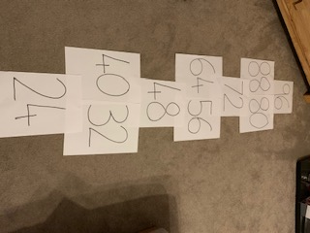
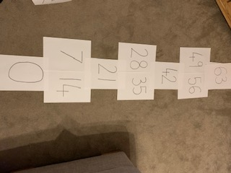

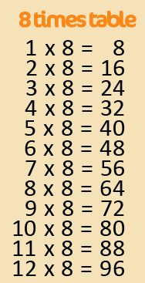
Can you encourage your parents, grandparents and siblings to join in too? Can you take a photograph or video of you taking part?
Challenge – Make a video of you practising and email to enquiries@ballifield.sheffield.sch.uk
FAO Mr Cassidy / Mrs Jenkinson.

Ask your adults to post to the
school’s Twitter page
@Ballifieldpri #activehomework

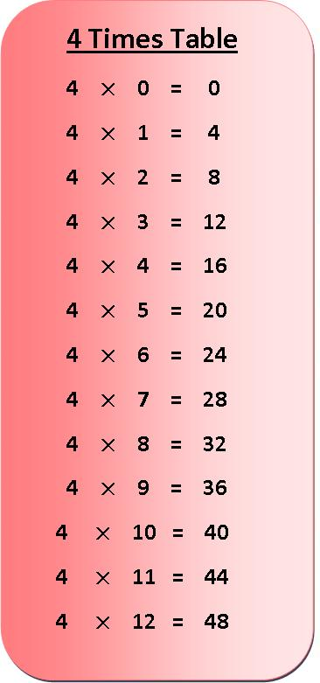
Active Times Table
Homework 3x & 4x
Hopscotch Times Tables

Practise the 3x and 4x tables and hopscotch together!

Make a hopscotch grid using your times tables. Use paper inside or chalk outside. Say the times table / answer the questions as you complete the hopscotch grid.

Can you encourage your parents, grandparents and siblings to join in too? Can you take a photograph or video of you taking part?
Challenge – Make a video of you practising and email to enquiries@ballifield.sheffield.sch.uk
FAO Mr Cassidy / Mrs Jenkinson.

Ask your adults to post to the
school’s Twitter page
@Ballifieldpri #activehomework

