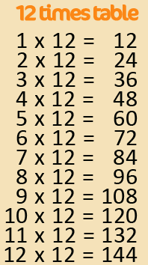
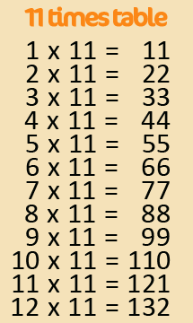
Active Times Table

Homework 9x, 11x, 12x

Practise the 9x, 11x and 12x tables by using a tennis ball.
One player option = Say a times table question and bounce the ball. You then need to say the answer before catching the ball.

Two player option = A parent or a partner of your choice shouts a times table question and bounces the ball to you. You need to say the answer before you’re allowed to catch the ball.

Can you encourage your parents, grandparents and siblings to join in too? Can you take a photograph or video of you taking part?

Challenge – Make a video of you practising and email to enquiries@ballifield.sheffield.sch.uk
FAO Mr Cassidy / Mrs Jenkinson.

Ask your adults to post to the school’s Twitter page @Ballifieldpri #activehomework
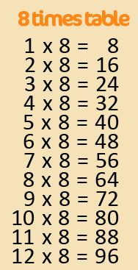
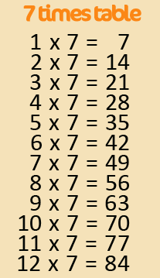
Active Times Table

Homework 6x, 7x, 8x

Practise the 6x, 7x and 8x tables by using a tennis ball.

One player option = Say a times table question and bounce the ball. You then need to say the answer before catching the ball.

Two player option = A parent or a partner of your choice shouts a times table question and bounces the ball to you. You need to say the answer before you’re allowed to catch the ball.

Can you encourage your parents, grandparents and siblings to join in too? Can you take a photograph or video of you taking part?

Challenge – Make a video of you practising and email to enquiries@ballifield.sheffield.sch.uk
FAO Mr Cassidy / Mrs Jenkinson.

Ask your adults to post to the school’s Twitter page @Ballifieldpri #activehomework

